Thank you for participating in our article series !

In order to help us and allow us to share your experience, please take note of the following elements we need of publish your article efficiently :

- Provide us with a picture:
  - A colored one and of the best possible quality
  - A professional picture (like LinkedIn or resume picture)
  - NO selfie or non professional picture
  - If you do not have any picture, the ISIPCA ALUMNI logo will be placed
- A logo of your company in order to get promoted on our vitrine page that promotes all the companies created by our alumni.

Before discovering the questions, here is a rendering of our publications on the various social networks - LinkedIn and Instagram:

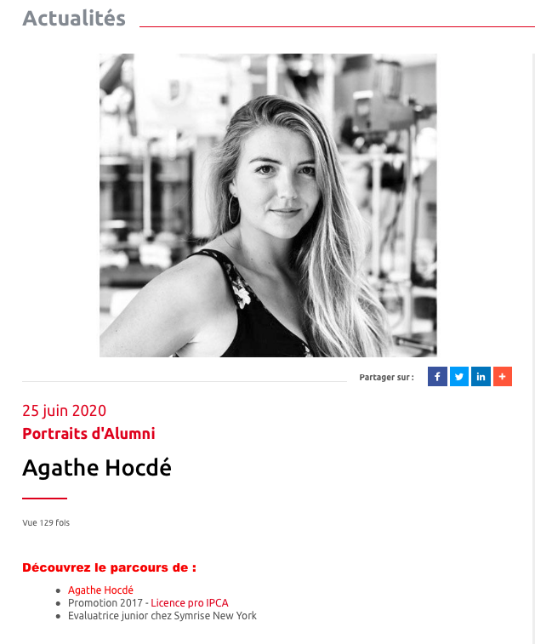

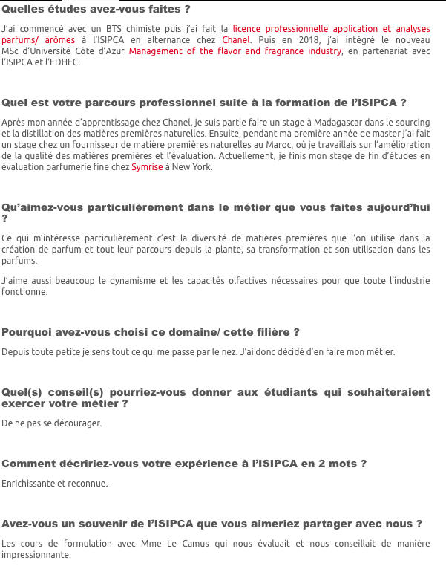
LinkedIn
Website

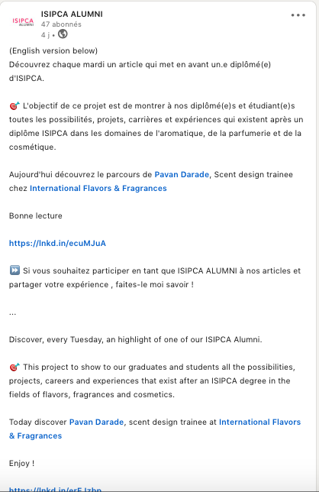
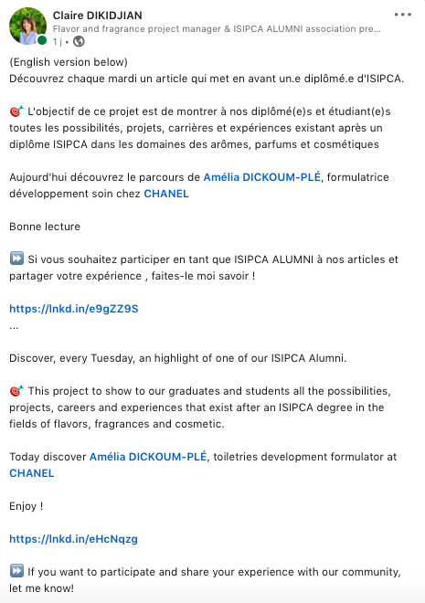

Instagram
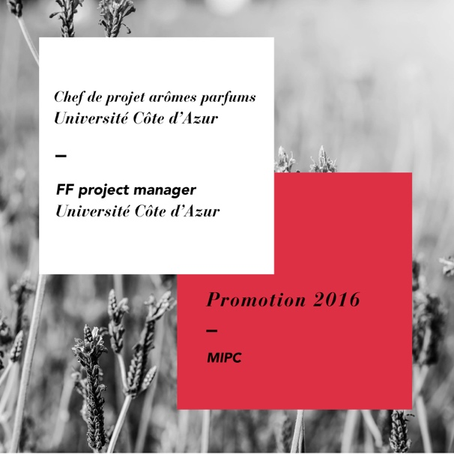
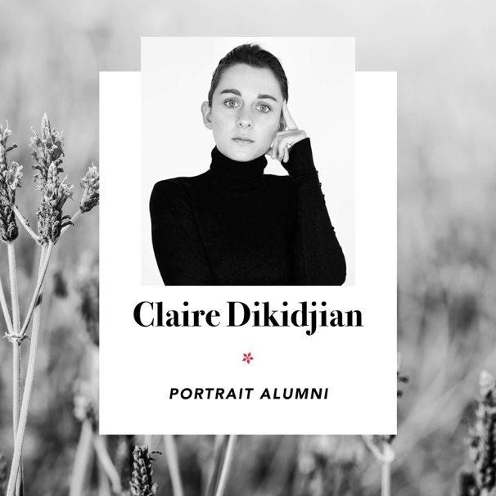

Vitrine page
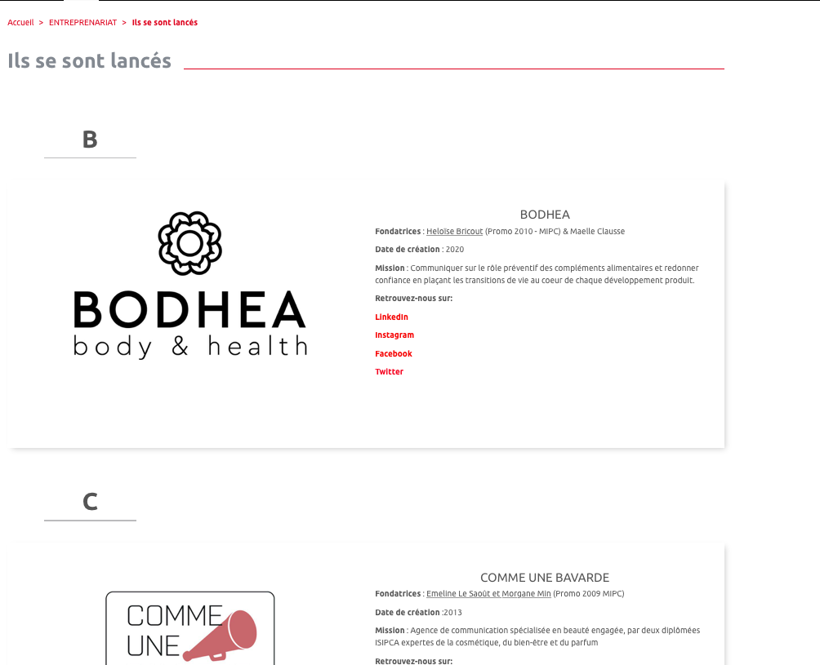

Here are the questions for the article :

- First Name Name (+ link of your LinkedIn profile)
- Promotion XXXX – Nom de votre diplômé
- Job title + Company name

What is your educational background?
What is your professional background after ISIPCA?
How did you get the idea for this project and how did you set it up?
What has been the greatest challenge you have overcome in your entrepreneurial
adventure? What barriers did you encounter and how did you overcome them?
What were the key moments that contributed to the success of this project?
What advice would you give to successfully manage the creation of a business?

Once we receive your questions, we’ll read it, translate it in French and send your the final rendering in order to let you validate everything !

Send us back your story : contact@isipca-alumni.fr

